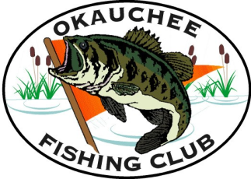Okauchee Fishing Club History

Founded on July 11th, 1967

1st Meeting—Hundler Hall, 6979 W. National Ave.

Past Presidents:
1967-1968 | Herb Albert | Herb Albert
1969-1970 | Jim Dahlk | Bill Binkleman (D)
1970-1971 | Ray Balcerczak (D) | Ray Balcerczak (D)
1972-1973 | Don Helwig | George Pazik
1974-1975 | Glen Runge(D) | Don Helwig
1975 | Dan Sura | Maurice Morasco (D)
1976-1977 | Roger Dellenbach(D) | Joe Ehrhardt (D)
1978-1979 | Dick Smith | Ray Schroeder (D)
1980-1981 | Ken Mahuta | Roger Dellenbach (D) DellenbacDellenbach(D)
1982-1983 | Steve Bilitz | Barbara Dellenbach
1984-1985 | Charles Smircina | Wally Wagner (D)
1986-1987 | Don Streeter | Dennis Cook
1988-1989 | Bill Bender | Dick Smith
1990-1991 | Larry O’Leske | Jim Wrolstad
1992-1993 | Doug Schrieber | Charles Smrcina
1993-1995 | Dave Nevinski | Glen Runge(D)
1996-1997 | Eric Catlin | Dan Sura
1998-1999 | Mike Miller | Jim Dahlk
2000-2001 | Harold Petsch | Don Streeter
2002-2003 | Eric Catlin | Larry O’Leske
2004-2005 | Scott Kuharske | Karen O’Leske
2006-2007 | Steve Mau | Eric Catlin
2008-2009 | Glenn Furst | Mike Miller
2010-2011 | Jim Dabisch | Lee Larsen
2012-2013 | Duane Marcell | Larry Pestor
2014-2015 | Jim Gilles

Honorary Members:
(D)—Signifies Deceased

